Emotions Recognition System

SRS Report



**Team Members**

Vinay Singh Parmar

(161500620)

Ravi Kumar Mishra

(161500442)

Vijay Kumar Sharma

(161500615)

**Table of Contents**

Revision History ii

Document Approval ii

1. Introduction 1

1.1 Purpose 1

1.2 Scope 1

1.3 APPLICATIONS..............................................................................................................................................1

1.4 Overview 1

2. General Description 1

2.1 Product Perspective 2

2.2 Product Functions 2

2.3 User Characteristics 2

2.4 General Constraints 2

2.5 Assumptions and Dependencies 2

3. specific Requirements 3

3.1 TOOLS Requiremets...............................................................................................................2

3.1.1 Hardware Requiremets............................................................................................ 2

3.1.2 Software Requirements.............................................................................................2

3.3 Functional Requirements 3

3.3.1 Use Cases..................................................................................................................... 3

3.4 Non-Functional Requirements 3

3.4.1 Performance 3

3.4.2 Reliability 3

3.4.3 Availability 4

3.4.4 Security 4

3.4.5 Maintainability 4

3.5 Inverse Requirements 4

4. Analysis Models 4

4.1 Data Flow Diagrams (DFD) 4

4.2 ENTITY RELATIONSHIP DIAGRAM 5

5. References 5

## 1. Introduction

Emotions in Social Psychology, in which it explained the emotion system and formally classified the human emotions through an emotion hierarchy in six classes at primary level which are Love, Joy, Anger, Sadness, Fear and Surprise. Certain other words also fall in secondary and tertiary levels. People are able to perfectly distinguish the expressed emotions because they understand the meaning of the words and phrases. They also are able to generate expressions and sentences for different emotions.

## Purpose

The main purpose of this project is to recognize the emotion for given text input and this SRS document is to provide a detailed overview of our software product, its parameters and goals. This document describes the project's target audience and its user interface, hardware and software requirements.

## 1.2 Scope

1. Text-Emotions Recognition System.
2. Our software will be able to recognize different types of emotions like Happy, Sad, Angry and Neutral.

**1.3 Applications**

1. Health care-patient feelings about treatment.
2. It can be used in call centers for user feedback.
3. Used for review mining of user feedback.
4. E-commerce sites etc.

## 1.4 Overview

1. Chapter 2 will provide the overall description of the application.
2. Chapter 3 will contain the Requirement Specification for the application.
3. Chapter 4 will contains the DFD and E-R diagram of the application.

# 2. General Description

Emotion recognition is the ability of a machine or program to receive and interpret dictation or to understand and carry out text commands. The project has takes text as input and provide corresponding emotion as output.

## 2.1 Product Perspective

There can be many products similar to emotion recognition system but their functionality may be different in context that they recognize human facial expressions or input text which can be used for some specific purposes.

## 2.2 Product Functions

This software will be able to recognize human emotions like happy ,sad, neutral , angry by taking the input as text and will be able to identify the type of emotion.

## 2.3 User Characteristics

It will be taking text of user as input so that it in this context text of user will be used. This would help to recognizing of emotions by the user.

## 2.4 General Constraints

Here the developers will be able to recognize the emotions with the help of 30,000 emotions data-set containing different text words for same type of emotions.

## 2.5 Assumptions and Dependencies

This software will be able to work upon on all of the operating system but under some conditions i.e. Required packages, Libraries, Tools, Running platform etc.

# 3.1 Specific Requirements

# 3.1 Tools Requirements

**3.1.1 Hardware Requirements:**

1. Laptop having Intel Core i3 processor with 4 GB RAM.

### 3.1.2 Software Requirements:

1. Jupiter Notebook.
2. Pandas.
3. NLTK.
4. Notepad.

## 3.3 Functional Requirements

## 3.3.1 Use Case:

SYSTEM

Input

Text

## 

Text

User Detection

Feature/Data

Extraction

Classification System

Emotion

## 3.4 Non-Functional Requirements

### 3.4.1 Performance

1. System should recognize to any text in his list without any fault.
2. With Ideal conditions, system response should be fast and error free.
3. System performance shall not decrease with time or by usages.

### 3.4.2 Reliability

1. The system can never crash.
2. The system must produce predictable result.
3. The system will be available 100% of the time.

### 3.4.3 Availability

This system will be up to date and offer all the facilities to the users. Also view the right detection.

### 3.4.4 Security

1. Change the data is only allowed to admins and forbidden to any user.
2. Program run without web, that is mean protected from hackers.

## 3.4.5 Maintainability

Software development team will be the maintenance team for any error or defect.

## 3.5 Inverse Requirements

1. It will not work on videos.
2. It will work on data set which we will give by text.

# Analysis Model:

# 4.1 Data Flow Diagrams (DFD)

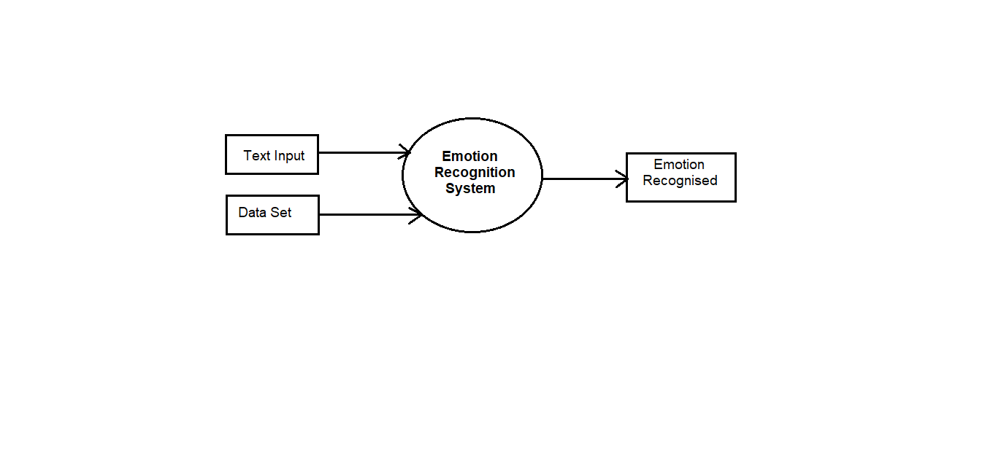

## 4.3 Entity Relationship Diagrams (ERD)

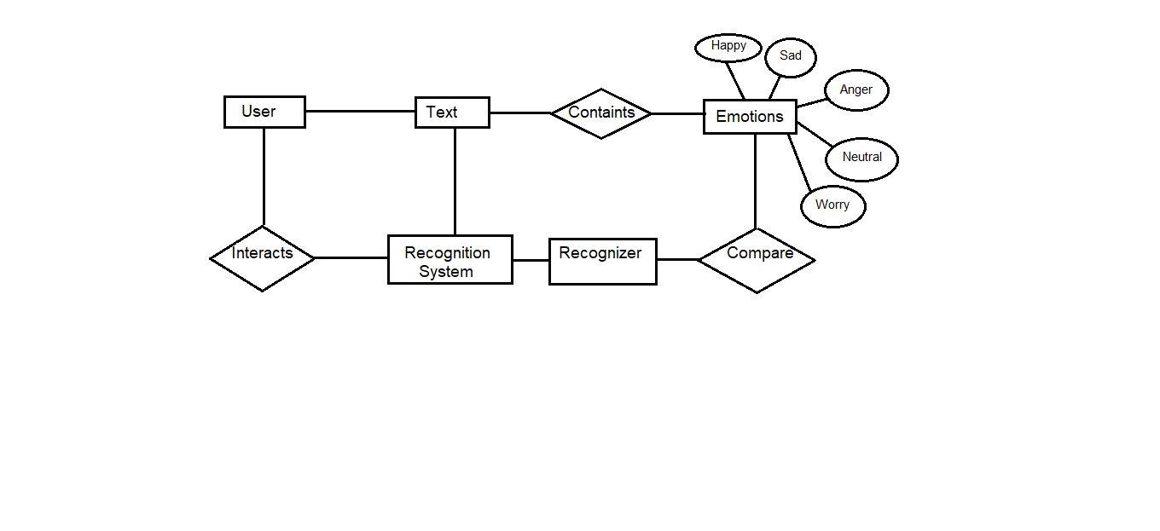**5. References**

1. <https://www.kaggle.com>
2. <https://www.google.com>
3. <https://www.udemy.com>